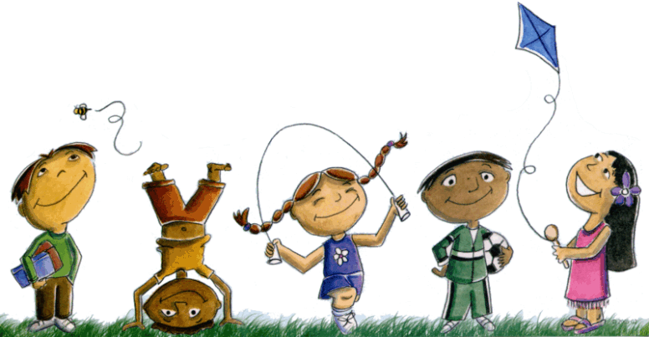
I am 2
It’s not easy. I’m realizing the world no
longer revolves around me like
it did when i was younger.

Still, life’s not so terrible. It’s just a bit
Complex and overwhelming at times.

I’m trying to understand the world
And my curiosity and drive sometimes
Look like trouble. I’m a force to be
Reckoned with, a busy brain on the go.

