Home Learning
Dear Parent,
Please do not feel under pressure with the weekly activities. You know your child best and not all children work at the same pace. Early Years is about learning through play.
I have tried to do a balance of play based work alongside more structured work. If your child was in Nursery I would know what way your child would engage best and teach them in a style that suits their learning.
Do not feel your child has to complete the activities I have set, these are a guide. You can dip in and out of the activities at your own leisure. I have probably put too much on, but this gives you a choice!

Name writing – before your child can write they need to have good fine motor manipulative skills.
If your child is struggling to write then focus on fine motor activities;
Lego, playdough, threading using beads or pasta, picking up small stones, gems, to make patterns or to go over letters of their name.
Use pegs to peg on to a box, Help peg out the washing. Use cooking tweezers to pick up small objects, Use buttons to make pictures, Complete jigsaws, Use scissors, Thread laces in holes in shoes, Place cheerios on to a straw

Let them draw, paint, colour – this will develop their pencil grip. If they are ready they can trace over their name – if they show an interest
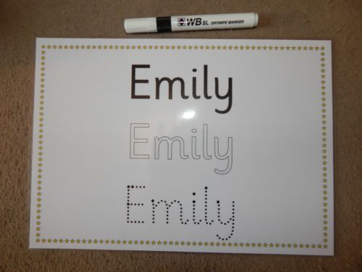

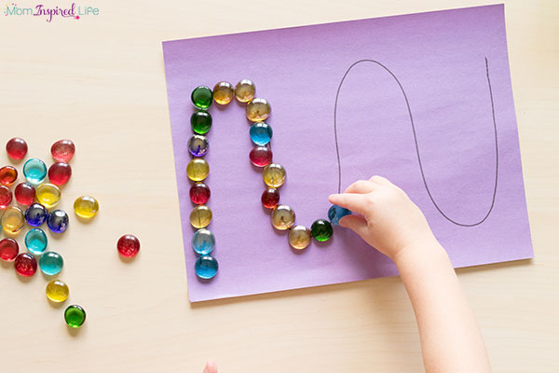

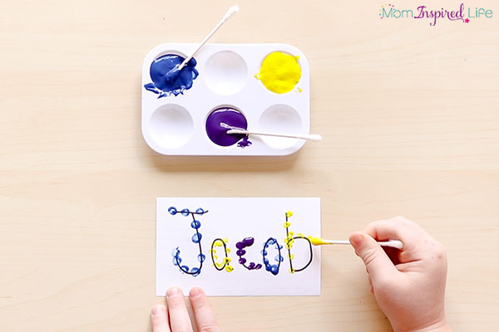

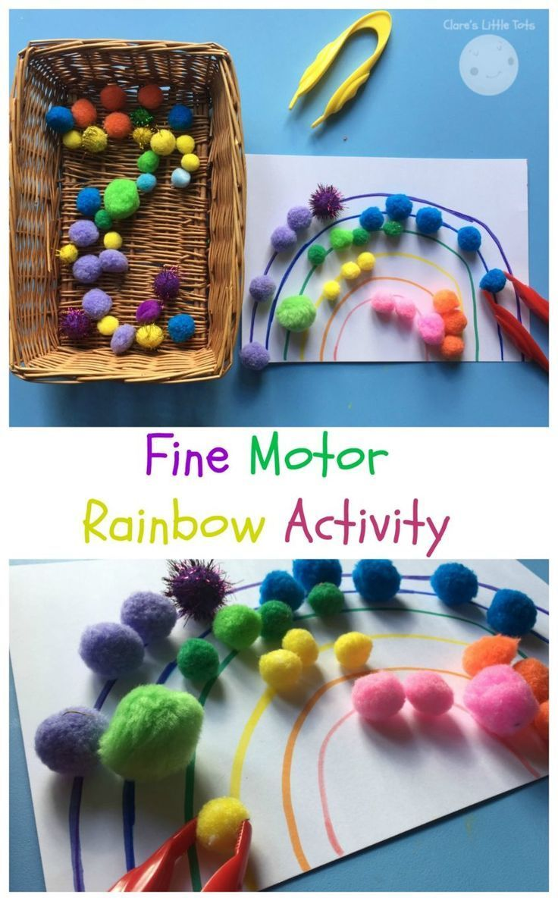
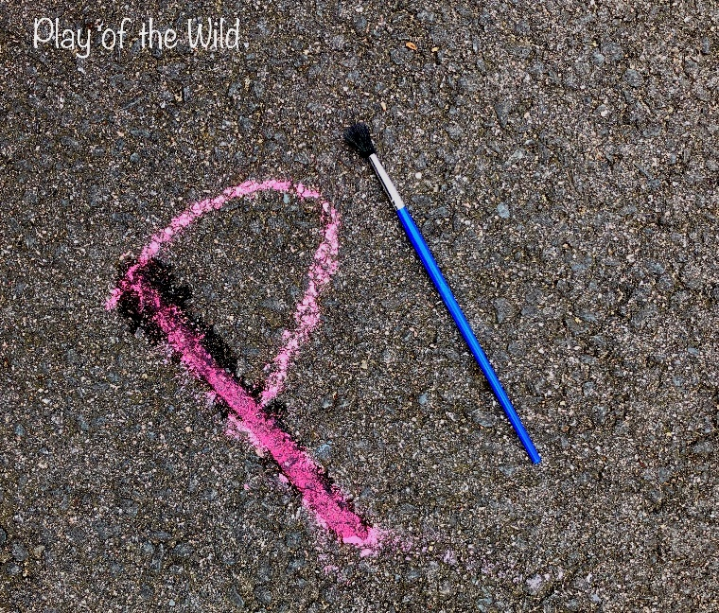

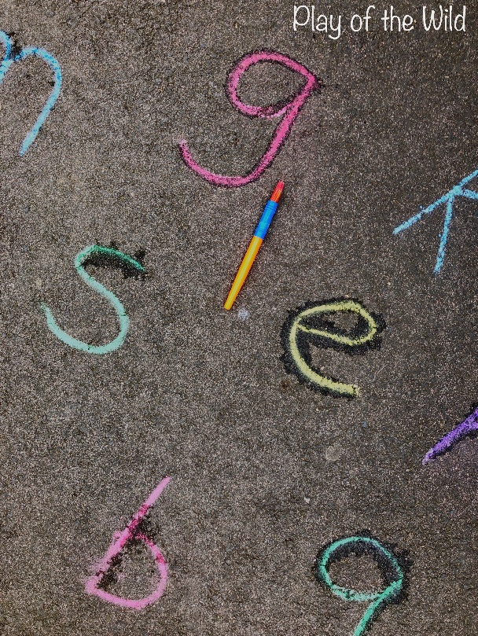

Communication and language
I would focus on lots on this( lots of speaking and listening games)
Games- I went to the shops and I bought ……
Tell me about (use random objects ; a banana, a pair of scissors, a spoon etc)
Look at different pictures or objects “what is it?”
What do you use it for?
Where might you see it?
Describe it; colour, taste, smell, size
I spy
Memory games, pairs
Go on a sound walk in the house, around the garden
Reading
Read books together, handle them correctly, talk about front cover
Predict what might happen
Talk about characters
Change your voice for different characters, let your child join in
Let your child retell the story
Play rhyming games
Play initial sound games; I spy, matching objects to letter sound.
Mathematics

Count out objects, small toys, use pointing finger to count.
Match objects to a numeral (If there are 4 toys, match with a number 4)
How many altogether (3 blue cars and 4 red cars, count how many altogether? 7 altogether.
Some children are using symbols + and = you can use these if you feel your child understands them.
Compare quantities, use language more, most, least, less, the same
Sing number Nursery Rhymes ( 5 little monkeys, 5 speckled frogs, 5 currant buns; you can find these on youtube or cbeebies
Watch number jacks (cbeebies)
There are always opportunities to count; count the stairs, count how many jumps to the end of the garden, count how many fairies, Pj mask figures you have

>Go on a shape hunt; talk about size, position of different shapes; The clock is a circle, the plate is a circle
> Look at different shapes in the environment
Use positional language; put the tiger on top of the box, under, behind, next to
Play number Bingo (numbers to 5, then 10)
Look for opportunities to identify & match colours; What colour is Leonardo’s eye mask? What colour is Elsa’s dress? Can you find me ...
There are lots of interactive mathematics games on ipads or tablets (look at cbeebies)

Physical Development.
Travelling in different ways in the garden; skipping, running, hopping,
Throwing and catching
Riding a bike, scooter
Hopscotch
Make an assault course, going over and under
Put on the music and dance using gross motor skills
Making Dens

Time to relax/Unwind
Turn TV off
Dim lights
Quiet, calming music (can play on phone from youtube, Alexa)
Read a story
Reflect

It is important for your child to have quiet time, to relax and feel at ease.

I hope this helps!
But again please do not feel under pressure to complete these activities. The joy with young children is that they learn best when they are playing and interacting. Most of the time they are unaware that they are learning.
During these uncertain times I want you & your child to be happy
Take Care
Mrs Foot

