Saints Peter and Paul Catholic Primary School

Key Stage One – Year 1/2

Class Bamber

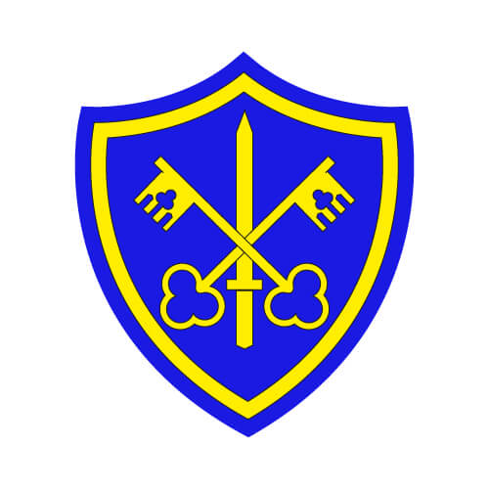

Autumn One

September to October 2021

**Home Readers**

* Read with your children on a regular basis and send the book back to school as soon as it is read fluently and understood. Talk to your child about the events in the story and what characters there are and what have they done.
* Home readers will be given out on **Monday**. They will be collected in on **Friday**.

**How to help your child at home:**

* Help your child with their homework which is uploaded to Class Dojo on Monday. There will be Maths and Spellings.
* Their spelling test will be on **the Friday** **of the same week the spellings are given out.**
* Talk and ask questions about your child’s day in school.
* Help your child learn number bonds which are addition and subtraction sums within 10 and 20.
* Help your child to practice handwriting and ensure that they can form their letters and numbers correctly whenever writing.
* Our PE Day is **Tuesday** afternoon. The children **come to school in their PE kit**. If the weather is cold, they can come in tracksuit over their PE kit.
* Snack money is £1 per week.

**English**

The children will continue to focus on Phonics through the Read Write Scheme. This term, we will be looking at a variety of stories and books to create different types of writing. Such as newspaper articles, recipes, descriptions and much more!

**The grammar we will focus on this term is;**

* Capital letters and full stops
* Question Marks
* Nouns, verbs and adjectives
* Exclamation marks
* Plurals

**Maths**

This term we will look at;

* Recognising numbers to 20.
* Addition and Subtraction
* Number bonds to 10 / writing numbers in words and numerals
* Building our knowledge of numbers!

**Topic – Art – Earth Art**

In this topic, the children explore how to paint on rocks, create sculptures using sticks, experiment weaving and using leaves to create pictures!

**Computing – Online safety and Exploring Purple Mash**

In this topic the children explore how to use the internet safely and responsibly. Also, we will recap how to log in and use Purple and Mash.

**Topic – Geography – Around the world**

This half term the children will follow Buddy the Bee and his adventures around the world. We will look at the continents, oceans and different cultures around the world.

**R.E**

**Families**

In this topic, the children will be able to talk about their experience and feelings about the roles of people within families. They will learn about God’s love and care for every family and how we show love to our family and to God.

**Belonging & Baptism**

In this topic, the children will have the opportunity to explore what different groups they belong to and how belonging to different things make them feel.

**Science – Plants**

Year 1 - In this topic, the children will learn about the structure of plants and trees and what they need to do to grow well. Also they will explore common plants and trees in gardens and in the wild. Children will plant their own bean and watch it grow over the weeks.

**Year 2 –** children will investigate different habitats, the animals that live in that habitat and what grows there. Children also explore local habitats to world habitats! We will explore food chains and how animals stay alive in the wild.

**PE- Exercise and Fitness**

They will learn a variety of skills such as balancing, jumping, throwing using equipment. They will complete activities such as sprinting, balancing beans bags and egg and spoon race.

**Music – Hey You**

Through the song ‘Hey You’, the children will learn about rhythm and pulse using different actions and parts of their body.