Saints Peter and Paul Catholic Primary School

Key Stage One – Year 1

Class Moore

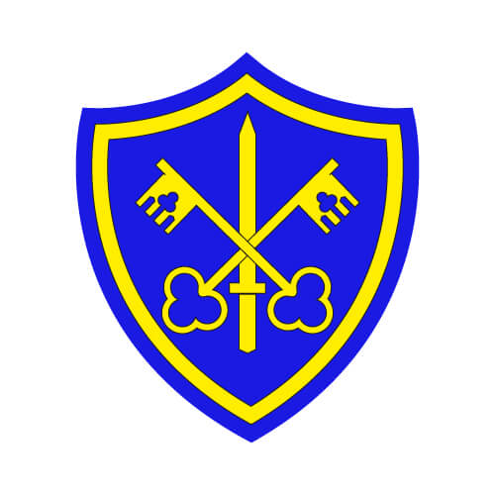

Autumn One

September to October 2021

**Home Readers**

* Read with your children on a regular basis and send the book back to school as soon as it is read fluently and understood. Talk to your child about the events in the story and what characters there are and what have they done.
* Home readers will be given out on **Monday**. They will be collected in on **Friday** to give them enough time to isolate for 72 hours.

**How to help your child at home:**

* Help your child with their homework which is set on Dojo on a **Monday**.
* Their spelling test will be on **the Friday** **of the same week the spellings are given out.**
* Talk and ask questions about your child’s day in school.
* Help your child learn number bonds which are addition and subtraction sums within 10 and 20.
* Help your child to practice handwriting and ensure that they can form their letters and numbers correctly whenever writing.
* Our PE Day is **Monday** afternoon. The children **come to school in their PE kit**. If the weather is cold, they can come in tracksuit over their PE kit.

**English**

The children will continue to focus on Phonics through the Read Write Scheme. This term, we will be looking at a variety of stories and books to create different types of writing. We will be writing an invitation, designing a garden, a newspaper report, instructions and much more!

**The grammar we will focus on this term is;**

* Capital letters and full stops
* Question Marks
* Nouns
* Exclamation marks
* Plurals
* Verbs

**Maths**

This term we will look at;

* Ordering numbers to 10; forwards and backwards
* Reading and writing numbers to 10
* Counting using resources and ten frames
* Doubles and halves
* Making number bonds

**Topic – DT – Moving Pictures**

In this topic, the children will learn about different ways to make a picture move! We will look at using levers, sliding mechanisms and more!

**Computing – E-Safety**

In this topic the children explore how to use the internet safely and responsibly.

**R.E**

**Families**

In this topic, the children will be able to talk about their experience and feelings about the roles of people within families. They will learn about God’s love and care for every family and how we show love to our family and to God.

**Belonging & Baptism**

In this topic, the children will have the opportunity to explore what different groups they belong to and how belonging to different things make them feel.

**Science – Plants**

In this topic, the children will learn about the structure of plants and trees and what they need to do to grow well. Also they will explore common plants and trees in gardens and in the wild. Children will plant their own bean and watch it grow over the weeks.

**PE**

**Exercise and Fitness**

They will learn a variety of skills such as balancing, jumping, throwing using equipment. They will complete activities that encourage children to stay fit and take part in different exercises.

**Music – Hey You**

Through the song ‘Hey You’, the children will learn about rhythm and pulse using different actions and parts of their body.