Year 4 Home Learning Timetable 22.02.21
 | Monday 22nd February | Tuesday 23rd February | Wednesday 24th February | Thursday 25th February | Friday 26th February
English | English – Taking Flight  Follow the link https://www.literacyshed.com/takingflight.html to watch the short clip, Taking Flight. Create Tony's internal monologue; taking place in the car on the way to Grandpa's house, whilst Dad is talking to Grandpa and then as the mood changes.  You can type your work on Dojo or add a picture to your portfolio if you have written your work. | English – SPAG  1)Practice these 5 spellings and put each into a sentence :  - Centre  - Century  - Certain  - Circle  - Complete  2) Complete the SPAG worksheet labelled SPAG-23.02.21  You can type your work on Dojo or add a picture to your portfolio if you have written your work. | English – Taking Flight  Follow the link https://www.literacyshed.com/takingflight.html to watch the short clip, Taking Flight.  Describe one of the adventures in detail. Start with the line, "I was travelling in the 'Radio-Flyer; when... "  You can type your work on Dojo or add a picture to your portfolio if you have written your work. | English – SPAG  1)Practice these 5 spellings and put each into a sentence :  - Consider  - Continue  - Decide  - Describe  - Different  2) Complete the SPAG worksheet labelled SPAG-25.02.21  You can type your work on Dojo or add a picture to your portfolio if you have written your work. | English – Taking Flight  Follow the link https://www.literacyshed.com/takingflight.html to watch the short clip, Taking Flight. Retell the story from Dad's point of view. How does he feel when he sees the two of them so dirty? What goes through his mind to change his mood?  You can type your work on Dojo or add a picture to your portfolio if you have written your work.
Maths | Multiply and divide by 9  Follow the link https://www.youtube.com/watch?v=cGsrC6ZPVGM  for a 9 times table recap and then complete the worksheets labelled ‘Year 4 Maths 22.02.21’ (This can be found on our class webpage and will be uploaded on Dojo) | 9 times table and division facts  Follow the link https://www.youtube.com/watch?v=cGsrC6ZPVGM  for a 9 times table recap and then complete the worksheets labelled ‘Year 4 Maths 23.02.21’ (This can be found on our class webpage and will be uploaded on Dojo) | Multiply and divide by 7  Follow the link https://www.youtube.com/watch?v=VEnQbnxWtqM&list=PLb7Q5jsm9eh_fdDPQmVpyp4XRu-raUbHc&index=6  for a 7 times table recap and then complete the worksheets labelled ‘Year 4 Maths 24.02.21’ (This can be found on our class webpage and will be uploaded on Dojo) | 7 times table and division facts  Follow the link https://www.youtube.com/watch?v=VEnQbnxWtqM&list=PLb7Q5jsm9eh_fdDPQmVpyp4XRu-raUbHc&index=6  for a 7 times table recap and then complete the worksheets labelled ‘Year 4 Maths 25.02.21’ (This can be found on our class webpage and will be uploaded on Dojo) | 11 and 12 times table facts  Follow the link for a video lesson  https://vimeo.com/490692507  and then complete the worksheets labelled ‘Year 4 Maths 26.02.21’ (This can be found on our class webpage and will be uploaded on Dojo)
Reading | Reading for pleasure. Read a book of your choice. Log on to Purple Mash to read a chapter of the book which has been set for you before answering the quiz questions. | Reading for pleasure. Read a book of your choice. Log on to Purple Mash to read a chapter of the book which has been set for you before answering the quiz questions. | Reading for pleasure. Read a book of your choice. Log on to Purple Mash to read a chapter of the book which has been set for you before answering the quiz questions. | Reading for pleasure. Read a book of your choice. Log on to Purple Mash to read a chapter of the book which has been set for you before answering the quiz questions. | Reading for pleasure. Read a book of your choice. Log on to Purple Mash to read a chapter of the book which has been set for you before answering the quiz questions.
Topic | Geography: Europe  European neighbours.  Follow the link below for today’s PowerPoint lesson. In this lesson you will be looking at the countries of Europe, their flag, currency (the money they use) and if they have a royal family.  https://drive.google.com/file/d/1I0S91gcMff-mNaN88pppskU02kvjokHL/view?usp=sharing  After you have gone through the PowerPoint complete the worksheet on Class Dojo, there will be an information sheet also on our class story to help. | Science: Sound  This term, you will be taught to:  identify how sounds are made, associating some of them with something vibrating  recognise that vibrations from sounds travel through a medium to the ear  find patterns between the pitch of a sound and features of the object that produced it  find patterns between the volume of a sound and the strength of the vibrations that produced it  recognise that sounds get fainter as the distance from the sound source increases  Look at the clip How sounds are made.  https://www.bbc.co.uk/bitesize/topics/zgffr82/articles/zstr2nb  Complete the quiz.  Log into Purple Mash to watch the sound slideshow that has been set as a ‘to do’. Finally, create a poster about how sounds are made using pictures and text from BBC and Purple Mash. Post the poster on Dojo. | Come and See: Reveal  Follow the link and listen to John Burland’s hymn – Gather together  https://www.bing.com/videos/search?q=john+burlands+gather+together&docid=608040419198043370&mid=241FC9508E5A01B16F79241FC9508E5A01B16F79&view=detail&FORM=VIRE  Read the REVEAL section. Choose one activity to complete. Post a photo of your work on Dojo. | Design Technology: American Food  Look at the American Food Slide Show.  Follow the recipe to make apple pie with your parent.  Post a photo onto Class Dojo.  This activity could be completed any time throughout the week.  If you are unable to bake, then watch the slideshow and make notes before posting a photo onto dojo. | Computing:Touch Typing  Log in to Purple Mash.  To Do’s will be set for you.  Look at:  Posture tips  Typing Instructions  Then move onto First Steps- Home, top and bottom row keys.  Complete:  3 activities for HOME KEYS  3 activities for BOTTOM ROW KEYS
 |  |  |  | Music: Lean on Me  Listen to the lyrics of Lean on me by Bill Withers.  https://www.youtube.com/watch?v=fOZ-MySzAac | Spanish: Puede  Log in to Spanish Angels Home Learning  Revise Unit1: Puede (I can…) This can be found in the ‘Entry Level Challenge’
Wellbeing/  Mindfulness | Follow the link: https://youtu.be/KAT5NiWHFIU  Zen Den: Superpower Listening. | Follow the link:  https://youtu.be/b5LLfdhGekA  Zen Den: Why are some people mean? | Follow the link: http://youtu.be/uUIGKhG_Vq8  Zen Den: The Listening Game | Follow the link:  https://youtu.be/xhWDiQRrC1Y Cosmic Kids Zen Den: The Very Hungry Caterpillar.  An activity which is a story incorporating Yoga. | Follow the link: https://youtu.be/KAT5NiWHFIU  Zen Den: We're Going on a Bear Hunt.
Physical activity | Please find below personal challenges which you can encourage your children to complete!  These will be updated weekly and we will promote the activities and challenges through our twitter account, @knowsleyssp , make sure you get involved and tweet us your results!  Follow the link:  http://knowsleyssp.com/kssp-personal-challenges/  Choose a challenge to complete each day. #StayInWorkOut #StaySafeStayActive
Come and See
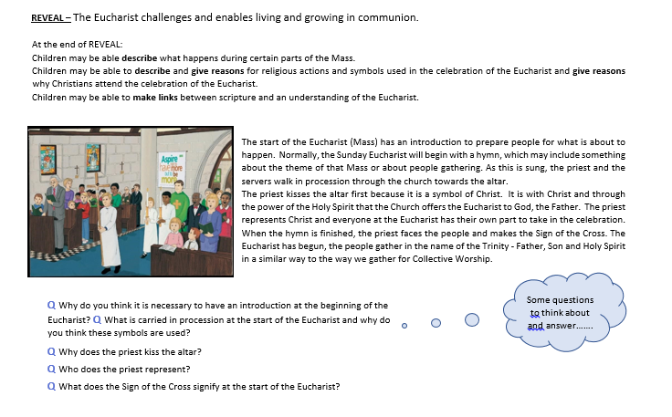
Choose one activity to complete:
After reading the words of John Burland’s, ‘Gather together’, write an additional verse to the hymn. Explain your choice of words and say why they are appropriate.
or
Write an account of what happens at the gathering of the Eucharist.
