 | Monday | Tuesday | Wednesday | Thursday | Friday
Activity 1  Physical Development | Boogie Beebies https://www.bbc.co.uk/programmes/b006mvsc  You choose are you going to be a dino or a penguin or monkey?  OR  Disney Shake up game  https://www.nhs.uk/10-minute-shake-up/shake-ups | Boogie Beebies https://www.bbc.co.uk/programmes/b006mvsc  You choose are you going to be a dino or a penguin or monkey?  OR  Disney Shake up game  https://www.nhs.uk/10-minute-shake-up/shake-ups | Boogie Beebies https://www.bbc.co.uk/programmes/b006mvsc  You choose are you going to be a dino or a penguin or monkey?  OR  Disney Shake up game  https://www.nhs.uk/10-minute-shake-up/shake-ups | Boogie Beebies https://www.bbc.co.uk/programmes/b006mvsc  You choose are you going to be a dino or a penguin or monkey?  OR  Disney Shake up game  https://www.nhs.uk/10-minute-shake-up/shake-ups | Boogie Beebies https://www.bbc.co.uk/programmes/b006mvsc  You choose are you going to be a dino or a penguin or monkey?  OR  Disney Shake up game  https://www.nhs.uk/10-minute-shake-up/shake-ups
Activity 2 | Sing our Good Morning prayer.  Sing the days of the week song.  Today is Monday. What can you think of starting with m  Monkey, mummy, Mcdonalds | Sing our Good Morning prayer.  Sing the days of the week song.  Check the weather; can you sing a song about today’s weather | Sing our Good Morning prayer.  Sing the days of the week song.  Today is Wednesday. Can you think of other things starting with ‘w’  Windy, water, wellies | Sing our Good Morning prayer.  Sing the days of the week song.  Check the weather; can you sing a song about today’s weather(Windy weather, Splish, Splash) | Sing our Good Morning prayer.  Sing the days of the week song.  Today is Friday. Can you think of other things starting with ‘f’  Fish, fingers, funny
Activity 3  Writing/  Fine Motor | Practise tracing or writing your name  Parent if you write your child’s name in a coloured pen and get them to trace it.  If they are confident doing this, then get them to copy their name independently.  See photograph below | Sing 1,2,3,4,5  Can you draw a picture of a fish | Magic writing  Write your name/trace the names of Sea creatures using a white waxed crayon  Paint over it in water coloured paints.  Ideas below | Practise tracing or writing your name  Parent if you write your child’s name in a coloured pen and get them to trace it. If they are confident doing this, then get them to copy their name independently.  See photograph below | Choose a fine motor activity below.
Activity 4  Communication & Language  Reading | Share the story of Fidgety Fish https://www.youtube.com/watch?v=TLW_jwXgbRg  Draw a picture of your favourite sea-creature from the story | Can you find out information about your favourite sea- creature  Telephone a family member to tell them about it. | Initial Sounds.  Put out objects beginning with the sounds ‘m’ and ‘a’  Identify what all the objects are; then sort them in to two groups  M sounds and a sounds  Emphasise the sound when saying each object; mmmmmm monkey  A,a,a,a,a apple | Come & See: Celebrations  Look at the activities set in the section REVEAL | Think of under the sea rhyming words.  Sea  Fish  Shell  Ray  sand
Activity 5  Mathematics | Count to 10  Magic hands counting to 10  Rocket ship counting to 10  (see if your child remembers the actions for these)  Show numerals 1-5 ask your child the number, then say the number with them.  Place 3 numerals on the table ask your child to find number 3. Put 3 objects on.  Find numeral 2, how many will you put on?  Continue challenge by using diff numerals  Challenge use numbers to 10 | Sing 1,2,3,4,5 once I caught a fish alive.  Draw fish and write numerals 1-4 on them  If your child is confident you can write numerals up to 10  If you want to play a fishing game cut them out and add a paper clip onto each fish, use a fridge magnet to pick them up.  How many did you pick up?  Challenge add the 2 | Can you make a fruit sundae or skewer (adapt questions to the fruit you use)  Choose your fruit! How many strawberries do you have? How many slices of banana do you have?  Do you have more banana slices or strawberries?  How many do you have altogether?  If you have grapes you have to cut them in ½ to be safe. How many whole grape do you have?  How many ½ ‘s do you have?  Send a photo of your fruit sundae or skewer | How many times can you ride your scooter to the end of the path?  How many times can you catch a ball?  How many times can you hop?  How many times can you kick the ball in the net?  (adapt these to child’s interests)  Record your answers  What did you do the most?  What did you do the least | Shapes in the environment,  Show your child a circle,  Go on a shape hunt around your house to find lots of circles; plate, clock, top of a cup, wheel, …..  How many circles did you find?  Can you order them small to big.
Activity 6  PSED  EAD | Mindful Monday  turn all the lights down/ tv off/ quiet, relaxing music  Create a quiet, calm space  Lay down, close your eyes  Slowly say these phrases with your child“ Relax my head, Relax my eyes, Relax my neck, Relax my shoulders, Relax my back, Relax my tummy, Relax my arms, Relax my hands, Relax my fingers, Relax my legs, Relax my feet, Relax my toes  Relax my body, Relax my mind | Get creative; make a sea creature of your choice  Ideas below | Wrap up warm and go for a walk: play what do you see, I see a ………….. | Sing baby shark  Can you use playdough to make your favourite se-creature | Choose a game to play with your family;  Bingo, Twister, Pop up pirate  One of your favourites!
Nursery Home learning ideas

Fine Motor Activites
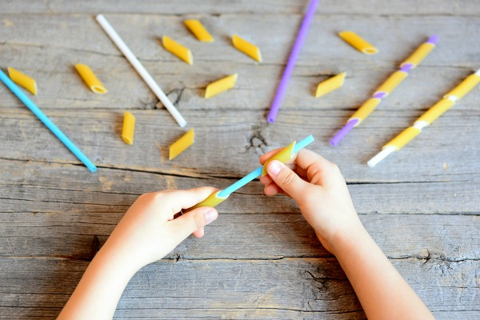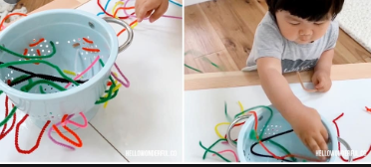

Simple threading activities using items like pipe cleaners or thread (even an old shoe lace) will enhance your child’s fine motor skills

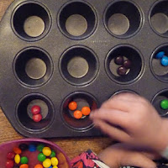
For the occasional treat why not let them sort their treats into a baking tray? This will develop sorting skills and fine motor... and you can bet they want to take part!
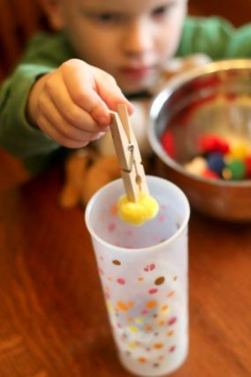
Activities with small items (age appropriate ensure there is no chance of choking) and tweezers helps to develop a pincer grip. No tweezers simple use a peg!
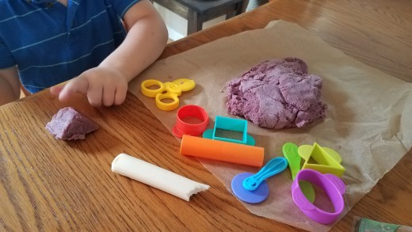
Roll, squash, squeeze and model that playdough!

See the link below for a homemade recipe from household ingredients

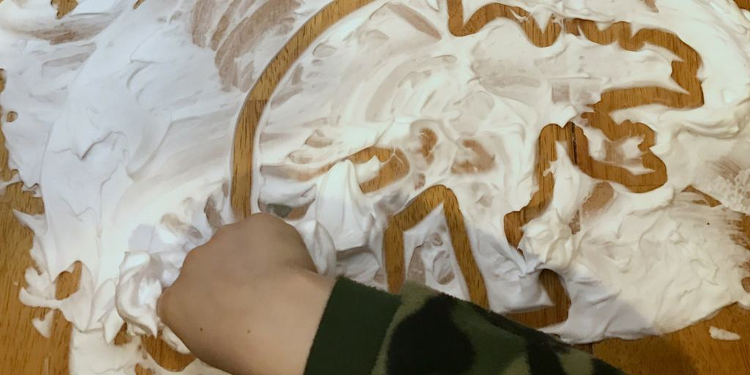
Cover a surface with shaving foam and let the children draw in it. Not only does it develop children’s fine motor skills it smells great too!
Supervise children to avoid them ingesting or getting in eyes.

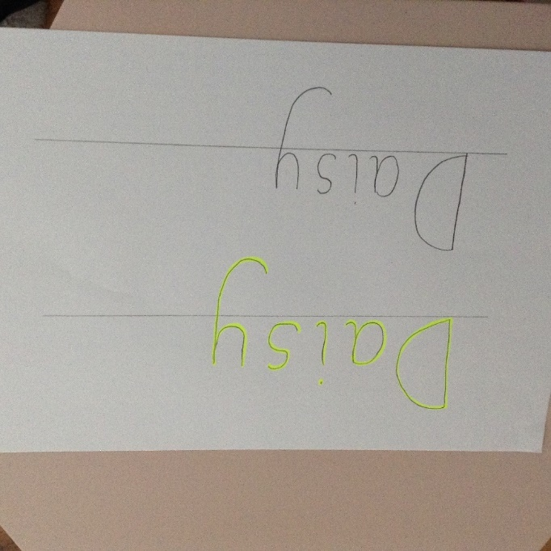
Write your child’s name in yellow, then ask them to trace their name over the yellow.
If they are confident in doing this, then get them to copy their name below. (as shown in the picture above)
If this is too tricky, then write the first letter of your child’s name and concentrate on 1 letter at a time.
