 | Monday | Tuesday | Wednesday | Thursday | Friday
Activity 1  Physical Development | Boogie Beebies https://www.bbc.co.uk/programmes/b006mvsc  You choose are you going to be a dino or a penguin or monkey?  OR  Disney Shake up game  https://www.nhs.uk/10-minute-shake-up/shake-ups | Boogie Beebies https://www.bbc.co.uk/programmes/b006mvsc  You choose are you going to be a dino or a penguin or monkey?  OR  Disney Shake up game  https://www.nhs.uk/10-minute-shake-up/shake-ups | Boogie Beebies https://www.bbc.co.uk/programmes/b006mvsc  You choose are you going to be a dino or a penguin or monkey?  OR  Disney Shake up game  https://www.nhs.uk/10-minute-shake-up/shake-ups | Boogie Beebies https://www.bbc.co.uk/programmes/b006mvsc  You choose are you going to be a dino or a penguin or monkey?  OR  Disney Shake up game  https://www.nhs.uk/10-minute-shake-up/shake-ups | Boogie Beebies https://www.bbc.co.uk/programmes/b006mvsc  You choose are you going to be a dino or a penguin or monkey?  OR  Disney Shake up game  https://www.nhs.uk/10-minute-shake-up/shake-ups
Activity 2 | Sing our Good Morning prayer.  Sing the days of the week song.  Today is Monday. What can you think of starting with m  Monkey, mummy, Mcdonalds | Sing our Good Morning prayer.  Sing the days of the week song.  Check the weather; can you sing a song about today’s weather | Sing our Good Morning prayer.  Sing the days of the week song.  Today is Wednesday. Can you think of other things starting with ‘w’  Windy, water, wellies | Sing our Good Morning prayer.  Sing the days of the week song.  Check the weather; can you sing a song about today’s weather(Windy weather, Splish, Splash) | Sing our Good Morning prayer.  Sing the days of the week song.  Today is Friday. Can you think of other things starting with ‘f’  Fish, fingers, funny
Activity 3  Writing/  Fine Motor | Practise tracing or writing your name  Parent if you write your child’s name in a coloured pen and get them to trace it.  If they are confident doing this, then get them to copy their name independently.  See photograph below | Sing Incy Wincey Spider  Can you draw a picture of Incy Wincy spider? | Choose a fine motor activity from below | Practise tracing or writing your name  Parent if you write your child’s name in a coloured pen and get them to trace it.  If they are confident doing this, then get them to copy their name independently.  See photograph below | Choose a fine motor activity below.
Activity 4  Communication & Language  Reading | Share the story ‘The Ugly Duckling with your child.  (If you do not know the story, it is available on youtube)  Talk about the word ‘ugly’ is it a nice word to use?  How did the ‘ugly duckling’ feel?  Talk about being unique  I am unique because…….. | Play a rhyming game:  Use real objects such as;  Pan, spoon, cat, dog, pen  Pick up the object and say a word that rhymes with it (pan, man) (pan, can) (spoon, moon)  Or  Use the pictures on the website | Share the story of ‘The Ugly Duckling’  What happens first?  What happens in the middle?  What happens at the end? | Come & See: Celebrations  Look at the activities set in the section Reveal | Environmental sounds:  Go on a sound hunt – wrap up warm and go on a walk or in the garden.  What sounds can you hear?  Are they quiet or loud?  Car, bus, people, birds, dog etc.
Activity 5  Mathematics | Count to 10  Magic hands counting to 10  Rocket ship counting to 10  (see if your child remembers the actions for these)  Show numerals 1-5 ask your child the number, then say the number with them.  Place 3 numerals on the table ask your child to find number 3. Put 3 objects on.  Find numeral 2, how many will you put on?  Continue challenge by using diff numerals  Challenge use numbers to 10 | Incy Wincy Spider has 8 legs.  Count to 8 tapping knee for each number. Count to 8 clapping  Count 8 fingers, show me 8 fingers.  Can you draw a spider? Give him 8 legs.  Can you make a spider: ideas below  Give him 8 legs. | Sing number Rhymes  5 Little ducks  Count to 5  Show 5 fingers (yr child will say high 5)  Use duck puppets made yesterday OR  Use fingers to represent ducks. Sing 5 Little ducks again.  How many are left when 1 swims away?  2 swim away?  3 swim away?  4 swim away?  5 swim away?  How many ducks are there with mummy duck?  Challenge different ways of making 5  0 and 5  1 and 4  2 and 3  3 and 2  4 and 1  5 and 0 | Count to 10  Magic hands counting to 10  Rocket ship counting to 10  (see if your child remembers the actions for these  Show numerals 1-5 ask your child the number, then say the number with them.  Play number Bingo using numerals to 5  Challenge use numerals to 10 | Big and Small  Can you find 3 small toys  Can you find 3 big toys  Can you order your toys in size order; small to big!  How many toys do you have altogether?  Challenge use more toys!
Activity 6  PSED  EAD | Explore: Winter weather  What is the weather like today? Wrap up warm go outside.  Is it icey? Is it raining?  If it is icey – What does it feel like? What happens when you touch it? Talk about the ice turning to water (melts) | Can you make duck puppets for tomorrow  ‘5 Little Ducks’ | Get Creative:  Can you paint, draw or use collage to make a picture of a duck OR a beautiful swan? | Come & See: Celebrations  Plan a party with your family, teddy bears/dolls  What food will you eat?  What games will you play | Come & See: Celebrations  Party Time with your family
Nursery Home learning ideas

Fine Motor Activites
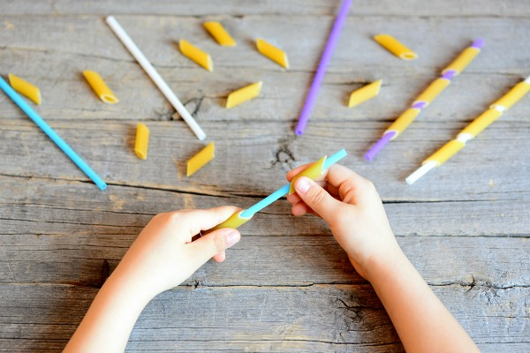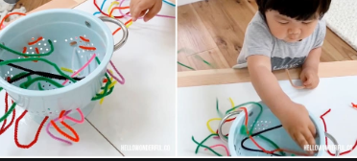

Simple threading activities using items like pipe cleaners or thread (even an old shoe lace) will enhance your child’s fine motor skills

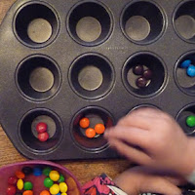
For the occasional treat why not let them sort their treats into a baking tray? This will develop sorting skills and fine motor... and you can bet they want to take part!
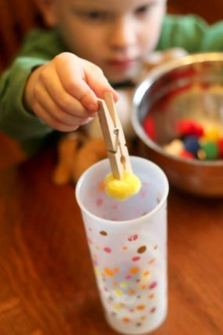
Activities with small items (age appropriate ensure there is no chance of choking) and tweezers helps to develop a pincer grip. No tweezers simple use a peg!
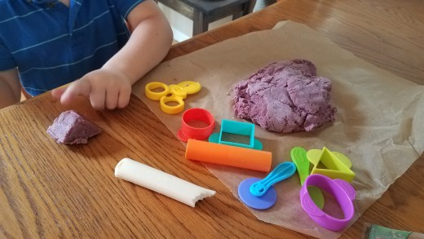
Roll, squash, squeeze and model that playdough!

See the link below for a homemade recipe from household ingredients

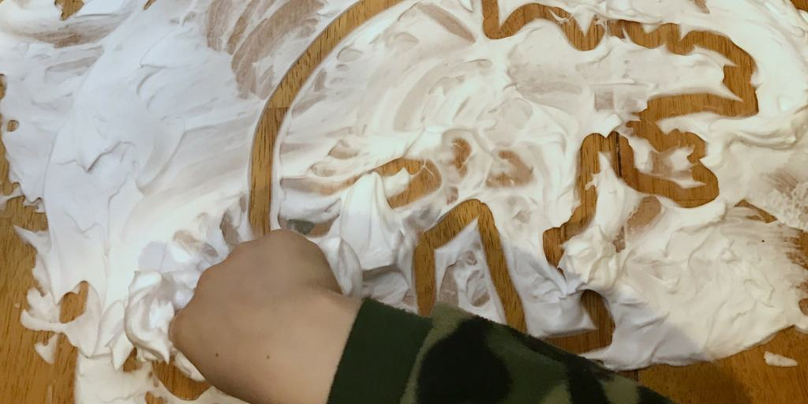
Cover a surface with shaving foam and let the children draw in it. Not only does it develop children’s fine motor skills it smells great too!
Supervise children to avoid them ingesting or getting in eyes.

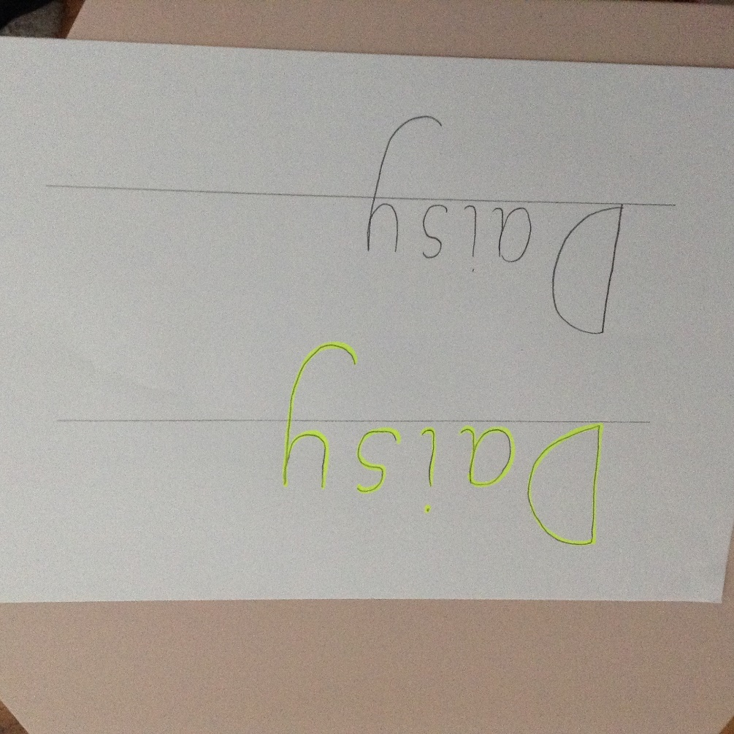

Write your child’s name in yellow, then ask them to trace their name over the yellow.
If they are confident in doing this, then get them to copy their name below. (as shown in the picture above)
If this is too tricky, then write the first letter of your child’s name and concentrate on 1 letter at a time.

