Saints Peter and Paul Catholic Primary School

Key Stage One – Year 1

Class Bamber

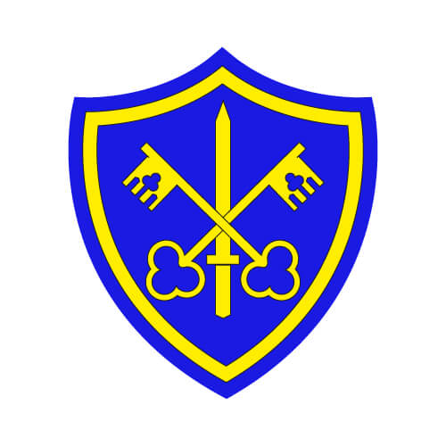

Autumn Two

November to December 2020

**Home Readers**

* Read with your children on a regular basis and send the book back to school as soon as it is read fluently and understood. Talk to your child about the events in the story and what characters there are and what have they done.
* Home readers will be given out on **Monday**. They will be collected in on **Friday** to give them enough time to isolate for 72 hours.

**How to help your child at home:**

* Help your child with their homework which is brought home on a **Monday**.
* Their spelling test will be on **the Friday** **of the same week the spellings are given out.**
* Talk and ask questions about your child’s day in school.
* Help your child learn number bonds which are addition and subtraction sums within 10 and 20.
* Help your child to practice handwriting and ensure that they can form their letters and numbers correctly whenever writing.
* Our PE Day is **Tuesday** afternoon. The children **come to school in their PE kit**. If the weather is cold, they can come in tracksuit over their PE kit.

**English**

The children will continue to focus on Phonics through the Read Write Scheme. This term, we will be looking at a variety of stories and books to create a variety of types of writing.

**The grammar we will focus on this term is;**

* Plurals
* Using –ed.
* Days of the week
* Using and
* Prefix un-
* Using –ing.

**Maths**

This half term we will look at;

* Counting forwards and backwards within 10
* Writing to 10
* Comparing and ordering numbers to 10
* Number bonds
* Addition and Subtraction to 10.

**Topic – History – Toys**

The children will have the opportunity to explore how toys have changed through time. The children will look at toys that their grandparents, parents played with and that they play now. We will then move on to create our very own toy museum.

**Computing – Lego Builders and Technology outside of School**

In this topic, the children will compare the effects of adhering strictly to instructions to completing tasks without complete instructions. They will explore how to follow and create simple instructions on the computer. Also, they will consider how the order of instructions affects the result

**R.E**

**Judaism**

In this topic, the children will explore Judaism. This focuses on Jewish beliefs and people such as Abraham.

**Hinduism**

In this topic, the children will explore and find out stories about KRISHNA AND GANESHA.

**Advent - Waiting**

In this topic, the children will have the opportunity to explore advent and focus on the loving relationships and the perfect gift and revelation of God’s love, Jesus.

**Science – Seasonal Changes – autumn to winter**

This half term the children will learn to recognise how leaves change over the year during the different seasons. The children will also learn about what happens to the weather in each season, what we wear and how the length of the day changes.

**PE - Bat and ball/co-ordination skills**

The children will explore holding a bat and tennis racket. They will learn how to hold them correctly, control balls in various ways and even hit targets.

**Music – Rhythm in the Way We Walk**

Through the song ‘Rhythm in the Way We Walk’ and ‘Banana Rap’, the children will learn about rhythm and pulse using different actions and parts of their body.

**Art – Colour Creations**

In this topic, the children will learn about primary colours, secondary colours, colour mixing and look at the artwork of artists who use colours such as Kandinksy and Mondrian.