Class Clitherow |  | Autumn term 1st half
Literacy | This half term the children will be taught Fiction and Grammar/Punctuation In Fiction, the children will be reading the novel ‘Who let the Gods Out?’ by Maz Evans and will explore the themes that arise in the text.  The children will be working hard to develop their writing skills, in particular developing their use of punctuation and expanding their use of more complex vocabulary. In grammar, the children will cover: singular and plural, modal verbs, relative clauses and active/passive voice.
Numeracy | Year Six will be:  - writing/reading/ordering and comparing numbers to 10,000,000  - round any whole number to a required degree of accuracy.  - Solving number problems..  - Multiplying a multi-digit number by a two digit number using long multiplication.  - Identifying common factors, multiples and prime numbers.  - Using BODMAS.
R.E | Loving |  | In this unit, children will explore the love and care of people. They will determine how God’s love is unconditional and never ending.
 | Belonging |  | Throughout this unit, children will explore commitment in life. Additionally, they will discover the vocation to the priesthood and religious life.

Science | Animals including humans | The children will be building on their knowledge and understanding of different systems within the human body. They will research the parts and functions of the circulatory system and look at how nutrients are transported around the body. They will start to explore how a healthy lifestyle supports the body.
ICT | Online safety  Coding | The children will be exploring Purple Mash this half term. They will also cover online safety and coding.
History | Ancient Greece | The children will be looking at Ancient Greece. They will be placing it on a timeline and finding out what the significant events were in that specific time period.
Art | Frida Kahlo | The children will have two full Art days at the end of this half term and will be looking at the artist Frida Kahlo.
P.E  (Wednesday) | Gymnastics | Children will be exploring taught Gymnastics with an instructor from Beth Tweddle’s company. They will experience general gymnastic skills, improve their fitness and take part in a display
Music | Pop music | The children will be covering a unit of work all about the song ‘Happy’ by Pharell Williams.
Spanish | Core vocabulary | The children will be revisiting: colours, days of the week, months of the year and numbers to 100.

How you can help your child make progress!

- Read with them several times a week and encourage them to read independently.

- Practice number facts regularly e.g. Times tables.

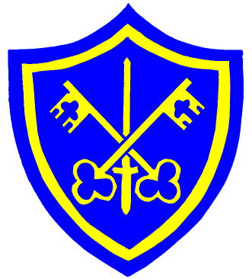
- Encourage them to learn spellings and complete all homework tasks on time.

- Keep an eye out for suitable programmes on T.V. that are related to what we are studying. The discovery channel often shows some good programmes.
- Discuss the plot, characters and conclusions of films, plays and soaps that you watch together
- Try to take them to the library or local museums so that they can find out further information about topics studied in class.

- Give them suitable responsibilities, to encourage independence.

Most importantly!

- Talk to them about their school day and ask them what they have learned. They will amaze you with what they get through in a day!

Homework

Maths:

Class Clitherow

Homework will be given out on a Monday and is due in the following Friday

Reading:

Children will need to bring in their book daily and take it home every night. With the books being more developed in Year Six, it is still important that you listen to and actively discuss the book that your child is reading.

Junior Department

Curriculum Outline
Autumn Term
2020 (1st half)

Spellings:
Spellings are given out at the start of term and your child will be tested the following Wednesday. It is imperative that they also know the meanings of the words that are included on their spelling list. Pass rate is 15/20.

Learning Log:

Year 6 children will be set a learning log to research fortnightly and this must be returned on a Friday. Each learning log must be two pages in length and can be handwritten or typed.

