 | Monday | Tuesday | Wednesday | Thursday | Friday
Activity 1 | Boogie Beebies https://www.bbc.co.uk/programmes/b006mvsc  Disney Shake up game  https://www.nhs.uk/10-minute-shake-up/shake-ups  Or P.E with Joe Wicks  9.00-9.30am | Boogie Beebies https://www.bbc.co.uk/programmes/b006mvsc  Disney Shake up game  https://www.nhs.uk/10-minute-shake-up/shake-ups  Or P.E with Joe Wicks  9.00-9.30am | Boogie Beebies https://www.bbc.co.uk/programmes/b006mvsc  Disney Shake up game  https://www.nhs.uk/10-minute-shake-up/shake-ups  Or P.E with Joe Wicks  9.00-9.30am | Boogie Beebies https://www.bbc.co.uk/programmes/b006mvsc  Disney Shake up game  https://www.nhs.uk/10-minute-shake-up/shake-ups  Or P.E with Joe Wicks  9.00-9.30am | Boogie Beebies https://www.bbc.co.uk/programmes/b006mvsc  Disney Shake up game  https://www.nhs.uk/10-minute-shake-up/shake-ups  Or P.E with Joe Wicks  9.00-9.30am
Activity 2 | Practise writing your name/surname  Challenge- extended family names (cousins, nan, grandad) | Practise writing learnt RWI sounds (m,a,s,t,d,n,i, p) say the writing phrase (in home learning booklet e.g Maisie, mountain, mountain)  Challenge- begin to write CVC words; dip, pip, tip, tin, pin | Practise writing your name /surname  Challenge- family, pet names | Practise writing learnt RWI sounds (m,a,s,t,d,n,i,p) say the writing phrase (in home learning booklet  Challenge- begin to write CVC dip, pip, tip, tin, pin | Make a card for your family member you are missing write their name
Activity 3 | Share your favourite story  Draw a picture of the characters in the story | Play an initial sound game  Get mum or dad to write letters on empty bottles – throw a pair of socks to knock the bottles down! Can you say the sound  Challenge – find an object beginning with the sound  Challenge make a word with the bottles | Share your favourite story again – child to retell it using intonation (different voices for different characters) talk about the author, illustrator, how you read the words left to right,  Can you describe the character; nasty, gruesome, cruel, beautiful, kind, a good friend ……. | Write outside using chalk, water and paintbrushes, stick in mud/sand  Make patterns, draw pictures, write cvc words  Mum/Dad good idea is for you to write in chalk, child go over it with paintbrush and water. | Draw a picture of all your friends  Can you write their names?
Activity 4 | Write numbers on card, paper or use numbers that you may have around the house (wooden, magnets)  Hide them in the garden  When you find all the numbers put them in the correct order!  Challenge – find the correct quantity of objects to go with each number | Count up to 10 using a ball or toy; parent starts; holding toy counts 1, child holds toy counts 2, parent holds toy counts 3 and so on. Continue to 20 if your child is confident. Challenge start from any number eg parent starts on 4  Play How many altogether (3 blue cars and 4 red cars, count how many altogether? 7 altogether. (use different objects) | Shape Sorter  Find different objects in your house garden that are a square, triangle, rectangle, circle  Which shape has the most objects?  Which shape has the least?  Can you count how many objects you have altogether? | Can you make a shape picture  Some ideas (print outs on website, or make your own)  A house  A Rocket  An animal  A castle | How many times can you ride your scooter to the end of the path?  How many times can you catch a ball?  How many times can you hop?  How many times can you kick the ball in the net?  (adapt these to child’s interests)  Record your answers  What did you do the most?  What did you do the least?
Activity 5 | Sunshine yoga; see activity book on website | Make a big hug to deliver to a family member or friend you a missing  See below | Make an obstacle course  Ideas below | You are my little superheroes. Make superhero props (mask, wristbands etc)  Printouts on website | Family fun time  It is the weekend ; plan a movie night- what will you watch, what goodies will you eat  Can you make a cinema ticket?
Nursery Home learning ideas
Please remember these are just ideas to add some structure to your child’s day, dip in and out of them as you wish, please do not feel pressure to do these activities, you know your child best. Stay Safe Mrs Foot x
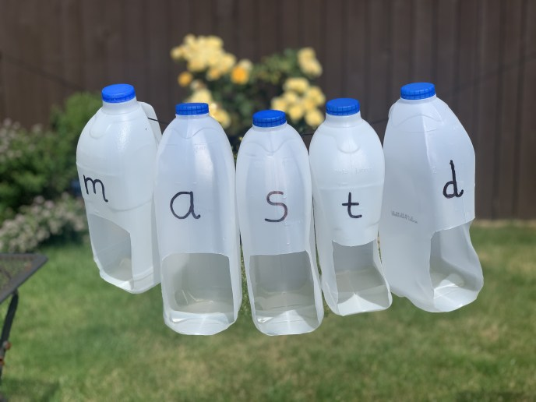

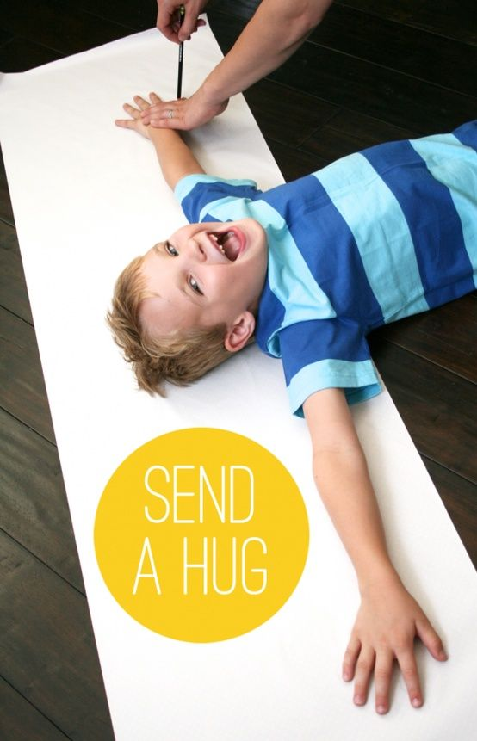
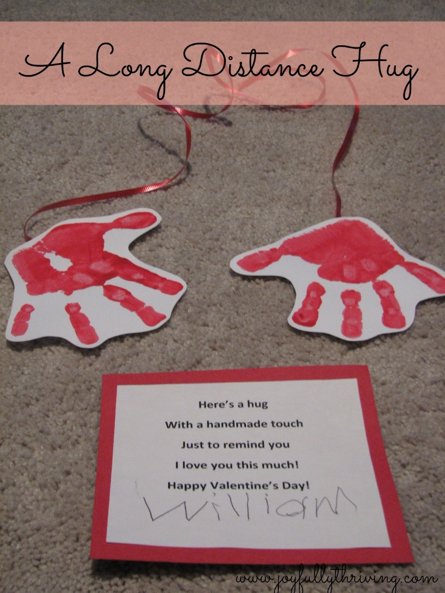 Leave out valentine message!

