Year 5 Come and See – Freedom and Responsibility.
Explore.
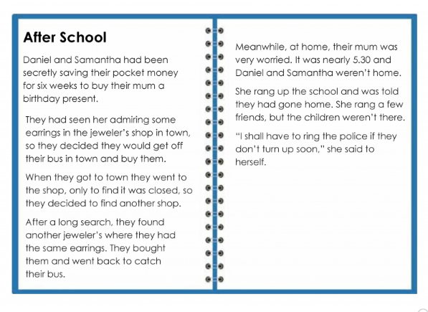
Read the following story and then, answer the questions below in your green books.
- What do you think happened when Daniel and Samantha got home? Why?
- What would the main issues be for Daniel and Samantha?
- What would the main issues be for their Mum?
- Has anything like that happened to you? What did you learn from the experience?
- What freedom does the Mother have a right to?
- What freedom do the children have a right to?

