[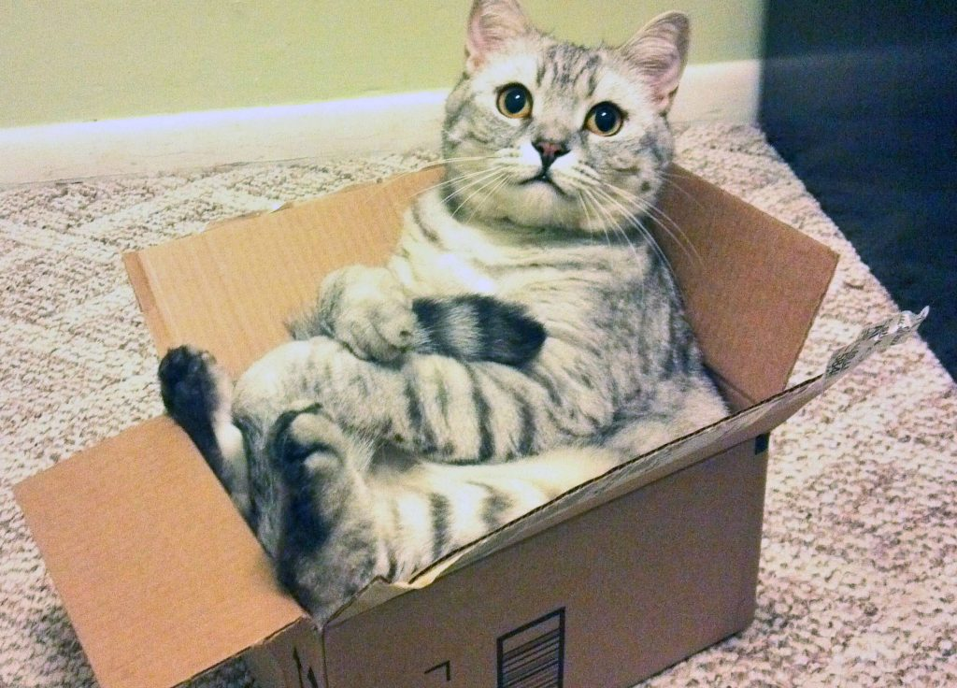](https://www.google.co.uk/url?sa=i&url=https://www.zmescience.com/science/why-cats-love-boxes-0432423/&psig=AOvVaw3XGgzZJ7nBOul4S9xjfJb7&ust=1586948519174000&source=images&cd=vfe&ved=0CAIQjRxqFwoTCIjj_4ri5-gCFQAAAAAdAAAAABAD)

The stripy cat is in the box.