Class | Howard |  | Summer term 1st half 2018
Literacy | This half term the children will be focusing on a mystery story called ‘Smash and Grab’. Following on from this the children will plan and write their own mystery story including a detective, suspects and clues.  As well as daily literacy lessons children will have an additional SPAG lesson each week focusing on various aspects of spelling, punctuation and grammar. This term we will be focusing on inverted commas (speech marks) as well as using apostrophes for possession (e.g. Jenny’s coat).
Maths | The children will begin by finding the area of a shape, they will look at area of squares and rectangles on a centimeter square grid before finding the area of rectangles and squares using only measurements and then finding the area of a triangle. The children will then move on to exploring the relationship between fractions and decimals. We will use a wide range of strategies to begin to solve fraction and decimal problem in order to be able to apply our knowledge and understanding.
R.E | Energy | Children will learn and discuss how Christians believe that the gift of the Holy Spirit within them gives them energy and the power to live the way of Jesus. The symbols used for the Holy Spirit – wind and fire – are symbols of power and energy. At Pentecost, the disciples were filled by the gifts of the Holy Spirit and went out courageously to carry the Gospel of Jesus to the whole world.
Science | Animals and their habitats | In this unit children explore a variety of ways to identify, sort, group and classify living things. They will learn how animals are split into vertebrates and invertebrates and begin to consider the differences between living things. They use and create classification keys to group, identify and name living things from the local habitat and beyond.
Topic  [Geography] | Villages and Travel | During this topic we will begin by looking at villages. The children will explore what makes a village, how villages are different and how villages can change over time. We will then move on to investigate different aspects of travel. We will look at different types of transport and use our map reading skills to find and plan different transport routes.
P.E  [Tuesday] | Applying Physical Skills | During PE, the children will apply the skills they have been developing to different styles. We will do this by playing a range of games that require the physical skills to be applied.
Music | Bringing us together. | In this unit all the learning is focused around one song: Bringing us together. The material presents a different approach to music where games, elements of music singing and playing instruments are all linked. As well as learning to sing, play, improvise and compose with this song, children will listen and appraise other disco songs that promote friendship, hope and peace.

How you can help your child make progress!

- Read with them several times a week and encourage them to read independently.

- Practice number facts regularly e.g. Times tables, bonds, double, half.

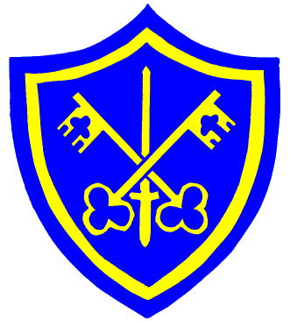
- Encourage them to learn spellings and complete all homework tasks on time.

- Keep an eye out for suitable programmes on T.V. that are related to what we are studying. The discovery channel often shows some good programmes.
- Discuss the plot, characters and conclusions of films, plays and soaps that you watch together
- Try to take them to the library or local museums so that they can find out further information about topics studied in class.
- Play board games, word games and number games with them.

- Give them suitable responsibilities, to encourage independence.

Most importantly!

- Talk to them about their school day and ask them what they have learned. They will amaze you with what they get through in a day!

Homework

Maths and literacy

Class Howard
Homework will be given out on Friday and needs to be handed in either before or on the following Friday. They should also be practising their number bonds and times tables regularly.
Learning logs
Learning logs will be given out twice every half term. The children will have two
weeks to complete their learning logs which should cover two pages in the log books.

Reading
Children will need to change their book at least once a week. Please listen to your child read, ask them questions about the book and comment honestly on how you feel they have read.

Junior Department

Curriculum Outline
Summer Term
2018 (1st half)

It would be a good idea to make sure the book is stored in their school bag to ensure that it comes to school every day and is not mislaid.
Children can change their book on any day.
Spellings
Spellings are given out on Friday and tested the following week alongside timetables
The children may also be given other homework each week related to work we are covering at the time.
PE
Class Howard will have PE on Tuesday afternoons this half term. Children should have a full PE kit in school for this day, including pumps.

